Luxoft is a top quality IT service provider of high-end business solutions to clients across the globe. With deep domain expertise in the finance, telecom, energy, automotive, travel and aviation industries, the company consistently goes beyond its clients’ expectations by bringing together technology, talent, innovation, and the highest quality standards.
Luxoft builds long-lasting partnerships with Boeing, IBM, Deutsche Bank, UBS, Harman, Avaya, Alstom, Sabre, Ford, Hotwire and many others by providing seasoned business and technology professionals, software imagineers, who deliver high-quality, innovative technology solutions that fit the client’s needs.
We offer international delivery capabilities through our network of state-of-the-art delivery centers around the world. Luxoft`s customers benefit from the right mix of technology skills, industry knowledge, proprietary processes and methodologies, and a choice of engagement models.

Join our Development Center in Luxoft Romania and become a member of our open minded, progressive and professional team.
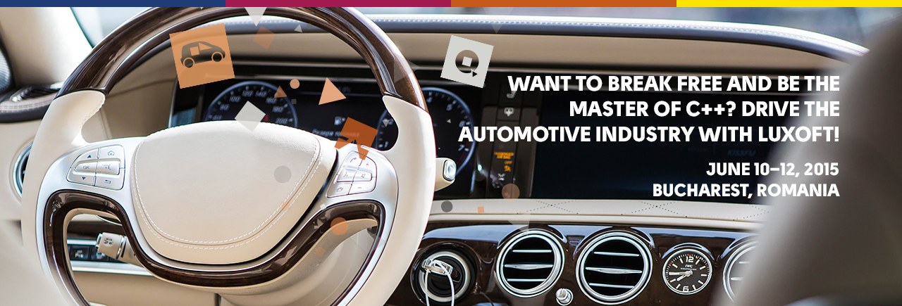
Currently we are looking for

Software Developer for Bucharest Location

Project Description:
Design and development of the Car Infotainment system from scratch. This includes all steps from righting requirements and understanding how the future car have to look like, through designing the SW system up to development and testing. It's a great opportunity to see and participate in a a world-wide product development from first ideas to the final release.
Used technologies include Linux, QT, customer specific protocols and frameworks. Used tools are based on production-grade generators and build toolchains.

Responsibilities:
Responsibilities cover full scope of the development process:
- Requirements development and analysis
- High-Level domain design development / improvement
- Component and code design
- Implementation of code and test cases
- Implementation of automated tests
- SW Testing of the developed code on the overall system

Skills Required:
Required general skills:
• Degree in Computer Science, Engineering or equivalent
• Strong knowledge of C++ and OOP programming
• Knowledge of SW design concepts, design patterns
• Fluent in English
Good to have skills:
• Knowledge of SW design concepts, design patterns, UML modeling
• Integration and build centrals systems knowledge

Learn more about Luxoft at www.luxoft.com

